High Plains Community Schools
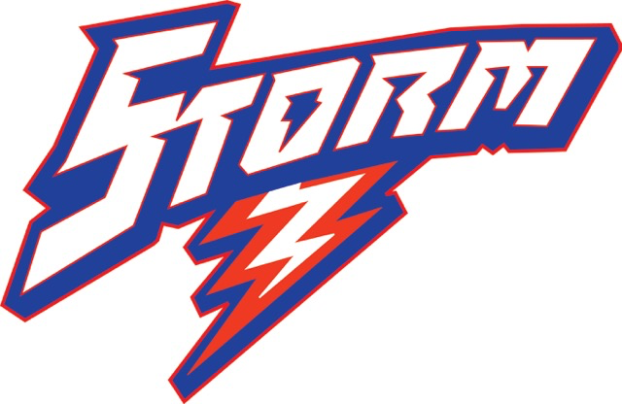
An Equal Opportunity Employer
Return to:
Brian Tonniges
260 S. Pine
Polk, NE 68654

Position applying for____________________________________________ Date:__________________
NAME____________________________________________________EMAIL:_____________________________
ADDRESS__________________________________________ S.S.#___________________________________
___________________________________________ PHONE________________________________
PREVIOUS EMPLOYMENT (list last three positions)
Employer | Position | Dates of Employment | Salary | Supervisor | Phone

WHEN AVAILABLE___________________________________________________________________
Education | Location | Dates of Attendance
Elementary
High School
College

Reference (List 3)
Name | Relationship | Phone

Comments:______________________________________________________________________________________________________________________________________________________________________________________________________________________________________________________________________________________________________________________________________________________________________________________________________________________

